Office Management System

Overview

Manage the use of on campus office space and keys for instructors and staff.
As determined by the chair or other administrator.

Programs
OM001 - OM099 database setup and listing programs Command line based
OM100 - OM199 Inquiry programs - Windows
OM200 – OM299 Maintenance programs - Windows
OM300 – OM399 assignment programs - Windows
OM400 – OM799 Unused
OM800 – OM899 = database programs

OM900 – OM999 Permission and other window related programs

Program # Description
OM001 create database
Create database on local machine

OM010 create database tables
Create tables on database

OM020 populate room table
Insert either test or production data into room table

OM022 populate instructor table
Insert either test or production data into instructor table

OM024 populate room / instructor table
Optional: insert instructor assigned to room into either the test or production database
Use the window program OM500 to assign instructor to room

OM026 populate key table
Insert either test or production data into key table

OM028 populate key / room table
Optional: insert key assigned to instructor into either test or production database
Use window program OM600 to assign key to instructor

OM095 dump selected table to output
Display selected table data to screen
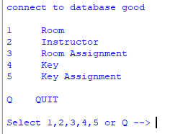
Select from menu to display contents of table
Note: output is displayed in IDLE shell

OM099 dump all tables to output
Display all tables to output
Note: output is displayed in IDLE shell

All window programs
All window program will attempt to open the database/
If successful, the window program will function
IF there is a problem with the database,
The following message box displays:
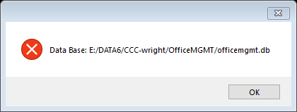
After selecting the “OK” button is selected.
Get the following message box:
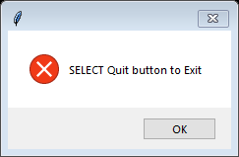
After selecting the “OK” button
Select the “QUIT” button on the screen/

Reason for the message boxes.
- Program cannot find the database
- Program cannot sign on to the database
- Unknown database error

OM100 Room Inquiry
Lookup by room number, get information
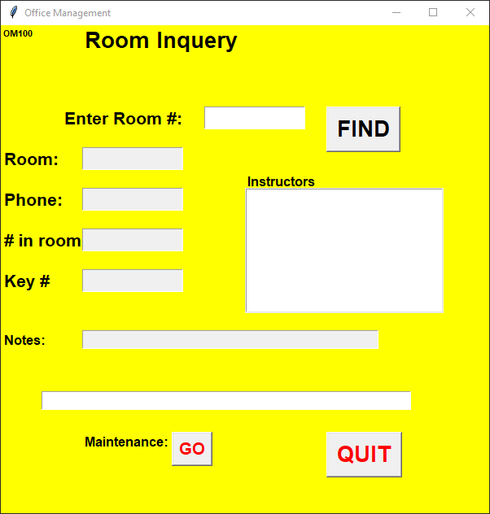
Operation
Type in room number in the “Enter Room#” box
If found: room number, phone number, # (number of staff) in room, key numbers,
Instructor assign to room and notes
If not found: message appears in bottom box
If you need to add or do maintenance to room,
Click on the “GO” buttom
GO button calls the Room maintenance program (OM200)

Room Number Found Room Not Found
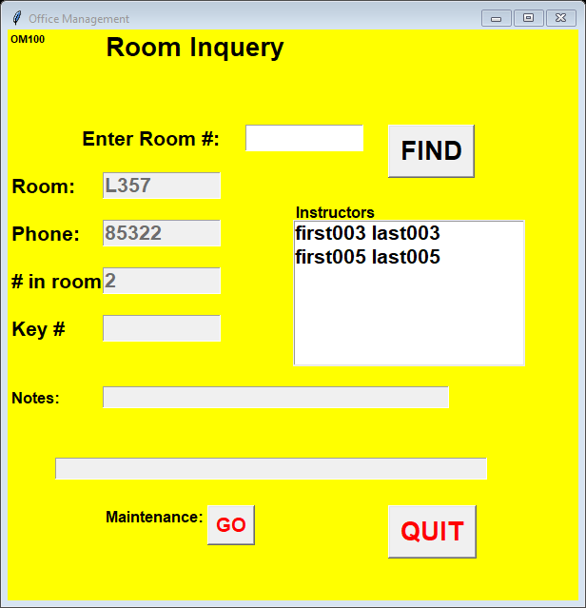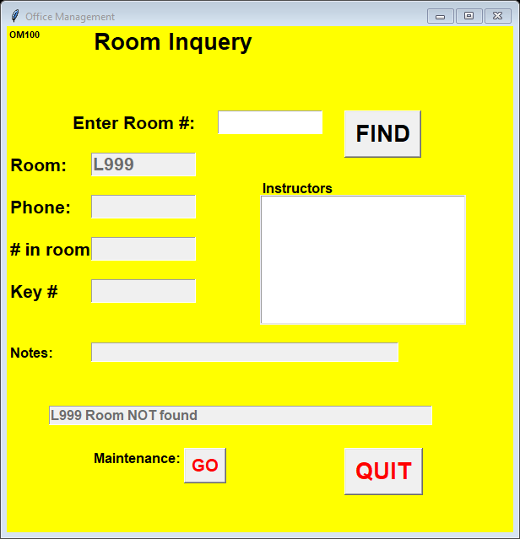
OM120 Instructor inquiry
To be defined
Similar to room inquiry

OM140 Key inquiry
To be defined
Similar to room inquiry

OM200 Instructor maintenance
Add / Change / Delete instructor from database

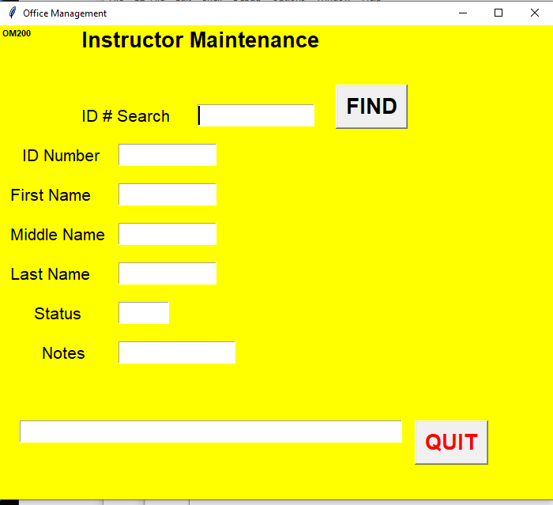

Operation
Enter Instructor ID number in the “ID # Search” box and select the “Find” button

If not found,
the “Add” button is displayed
and the required fields are highlighted in green.
Once the fields are filled in, select the add button.
When the data is successfully added to the database, a message is displayed

OM200 continue instructor maintenance
Add instructor
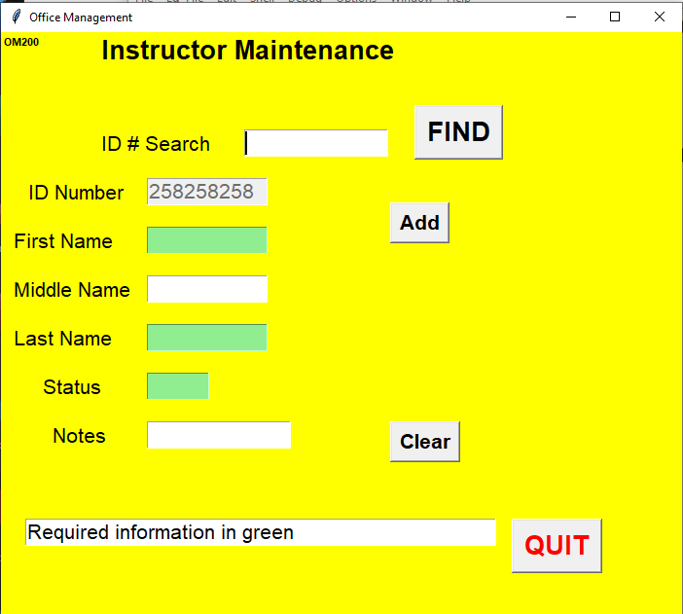

The field highlighted in green must be filled in (cannot be blank)
Required fields (information):
- First Name
- Last Name
- Status (F-Full time, A-Adjunct, O-staff)
Optional:
- Middle name
- Notes

After “Add” button has been selected
Message is displayed that instructor is added to database

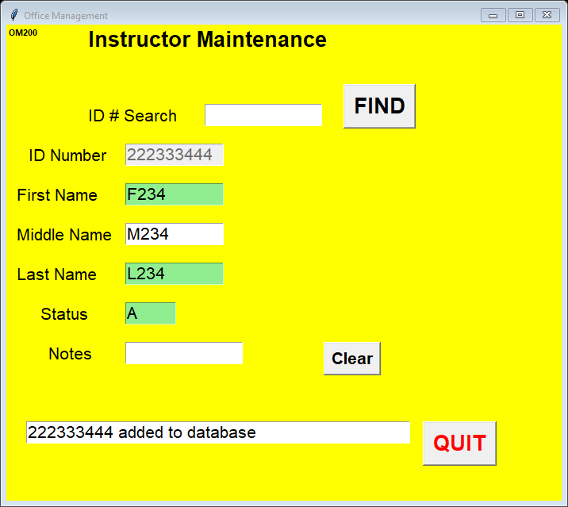

OM200 continue instructor maintenance
If fields are not filled in:

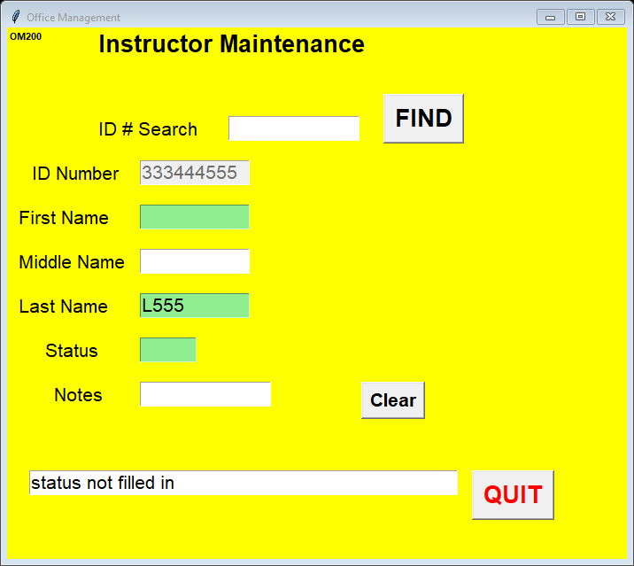
Message is displayed indicating the missing fileds

If instructor number is found;

The following buttons are displayed:
“Update” (change) the instructor information
“Delete” remove instructor from database

Delete
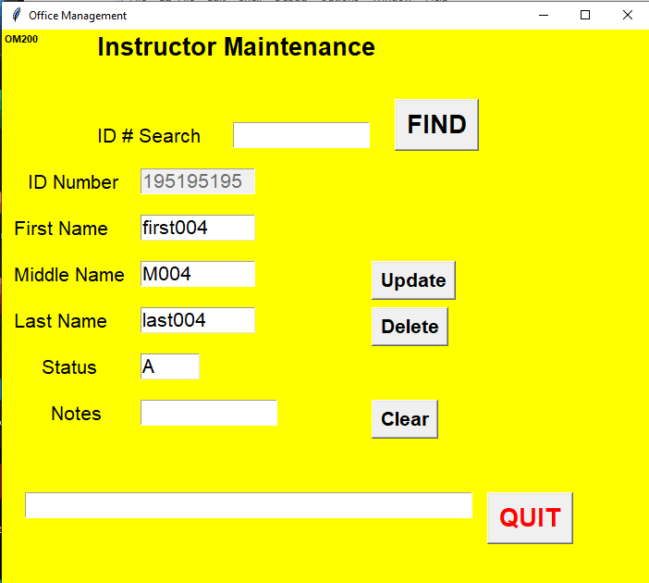

Delete Rules:
• Cannot be assigned to a room
• Cannot be assigned (have) keys

OM200 continue instructor maintenance
Select the “Delete” button to remove the instructor information from the database
A “Are you sure” message box is displayed

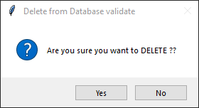

Select the “No” button and record IS NOT deleted.
The ‘cancel message’ is displayed.

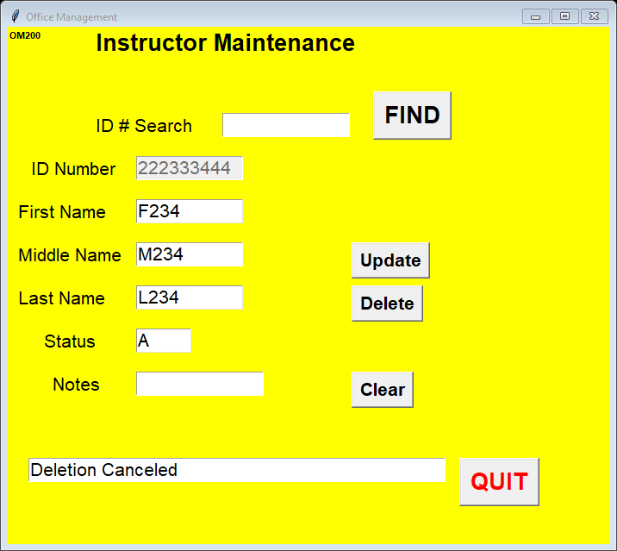
Select the “Yes” button and the record is deleted.
When the record is successfully deleted, a message is displayed.

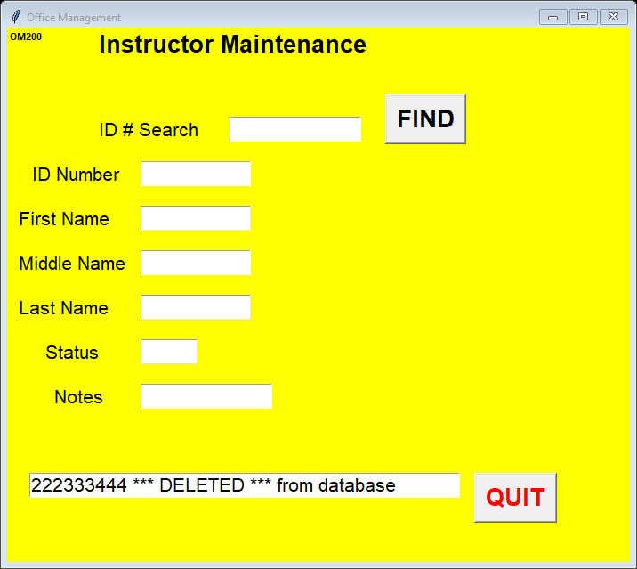

OM200 continue instructor maintenance

If the deletion of the record fails, a message will be issued as to possible cause of the failure.
Failure reason:
- Instructor assigned to a room
- Instructor assigned keys
- Database error

Change (Update)

The following fields can be changed:
- First Name
- Middle Name
- Last Name
- Status
- Note

The following fields can not be change to blank:
- First Name
- Last Name
- Status

OM200 continue instructor maintenance
Error fields will be highlighted in red and An error message will be displayed.
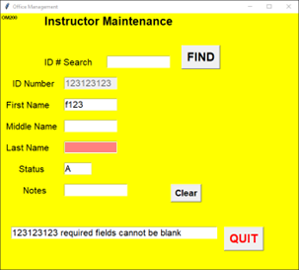

Clear button
Selecting the clear button will reset the window to the beginning.
All the boxes will be empty and ready for next instructor number.

Result of selecting the “Clear’ button
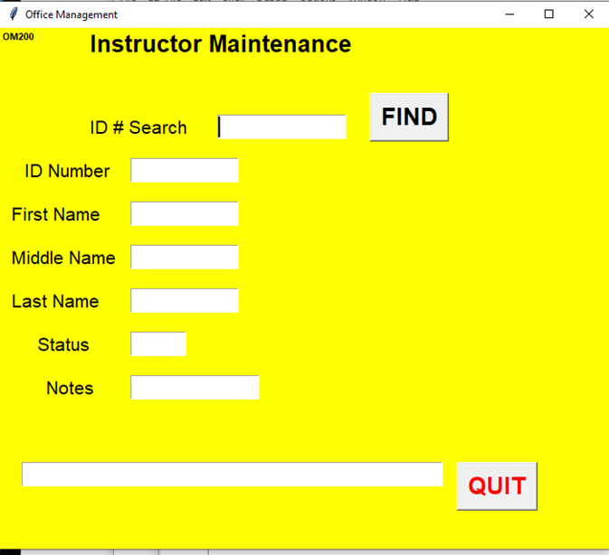

OM220 Room Maintenance
Add/change/delete room number from database
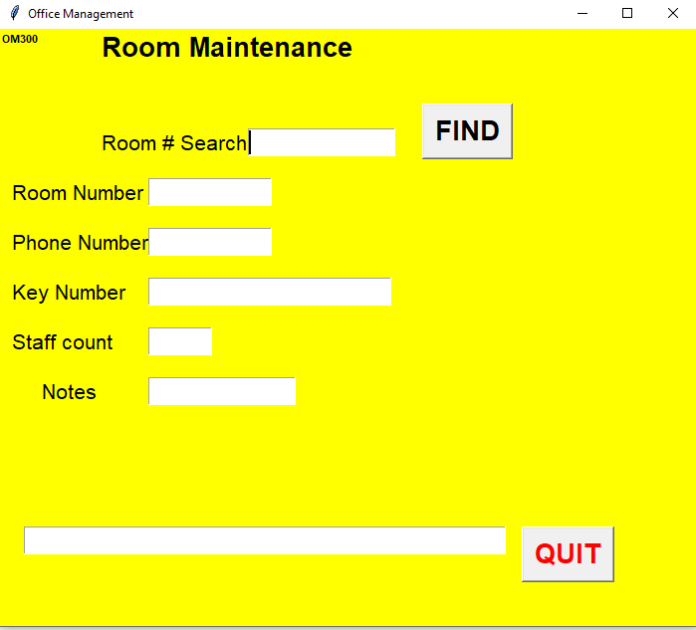
Add room
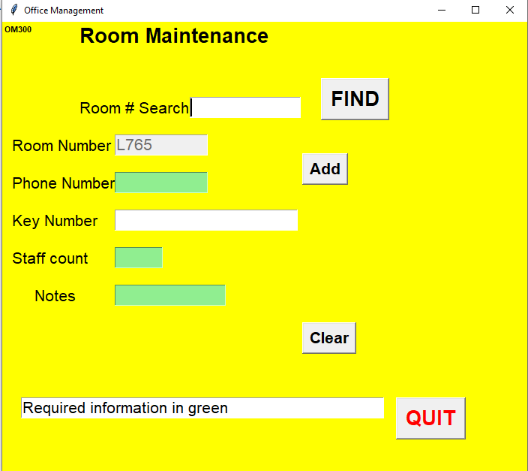
Change (update) or delete room number from database
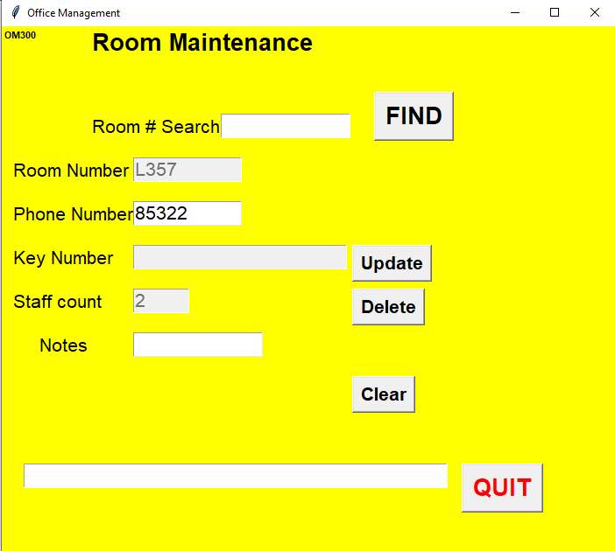
OM220 continue
Delete:
Rules: cannot delete room if connected to a person

OM240 Key maintenance
Add/change/delete key (by number) from database
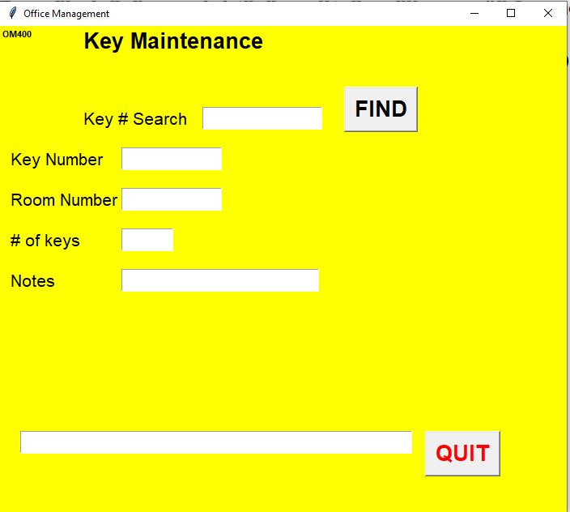
Add Key
Not ready
Change (update) or delete key
Not ready
Delete::
Not ready
Rules: cannot delete in connected to a person

OM300 Room assignment

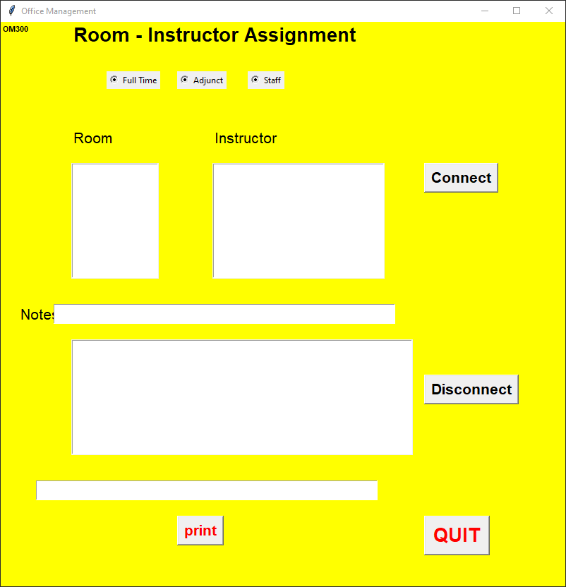
1 continue instructor maintenance
2
3
4
Select personnel type to connect (assign) to a room
Full time: Professor and other full time, one per room
Adjunct: All part time, up to 4 per room
Stall: NOT full time or adjunct no limit to room
ONLY one can be selected
Title of box changes based on selection (see #4)
OM300 Continue
When select button is clicked:
Full Time:
- List all Full Timers that are in an assigned room in lower box (Box #3)
- List rooms with nobody in then in left box (Box #1)
- List Full Timers not assigned a room in right box (Box #2)
Action: the connect and disconnect button work the same for all 3 categories

Adjunct:
- List all Adjuncts that are in an assigned room in lower box (Box #3)
- List rooms with less than 4 adjuncts in then in left box (Box #1)
- List Adjuncts not assigned a room in right box (Box #2)
Action: the connect and disconnect button work the same for all 3 categories

Stall:
- List Staff that are in an assigned room in lower box (Box #3)
- List rooms with staff in then in left box (Box #1)
- List staff not assigned a room in right box (Box #2)
Action: the connect and disconnect button work the same for all 3 categories

Action: Connect
To connect room to person, Highlight the room (only one) and highlight the person (only one)
And select the Connect button.
If successful, the connect is move to lower box (box #4)
And removed from left and right box ( box #1 and box #2)

OM300 continue room assignment

Disconnect
In the list in lower box (box #3), highlight the room / person.
Select the disconnect button
The highlighted will be removed from the lower box (box #3)
And the room and person will be added back the left and right box (box #1 & Box #2)

Rules:
Room must be on the room table
Person must be on the instructor table

Left box (box #1) and lower box (box #) will display room number order (sort by room number)
Right box (box #2) will display in alphabetic order

.

OM320 Key assignment
Similar to room assignment
Assign key to room
Not ready
Assign
Not ready
Unassign
Not ready

OM800-899 database utilities
OM800 select table (key, instructor or room)
List table contents to screen
OM820 List room assignment table to screen
OM840 list key assignment table to screen

OM900 permission maintenance
Set who can update the database
On the inquiry programs, the “go” button will not display if the person using the program does not have permission to make changes

The permission file is either a flat file or a single table on the database
Design to be determine (name & keyed by initials ?)

To Be defined
Print (to printer) request (actually write a flat file that can be used by excel or word)
Database maintenance (backup, create, etc)
Office management profile (configuration) file
Has number of adjuncts in office, path to database, etc
Create search window(s)

